**OPERATING SYSTEM LAB**

NAME: CHARAN KUMAR REDDY M

ROLL NO: CB.EN.U4CYS21041

**1.**

#include<stdio.h>

int main()

{

int bt[20],p[20],wt[20],tat[20],i,j,n,total=0,pos,temp;

float avg_wt,avg_tat;

printf("Enter number of process:");

scanf("%d",&n);

printf("\nEnter Burst Time:n");

for(i=0;i<n;i++)

{

printf("p%d:\n",i+1);

scanf("%d",&bt[i]);

p[i]=i+1;

}

//sorting of burst times

for(i=0;i<n;i++)

{

pos=i;

for(j=i+1;j<n;j++)

{

if(bt[j]<bt[pos])

pos=j;

}

temp=bt[i];

bt[i]=bt[pos];

bt[pos]=temp;

temp=p[i];

p[i]=p[pos];

p[pos]=temp;

}

wt[0]=0;

for(i=1;i<n;i++)

{

wt[i]=0;

for(j=0;j<i;j++)

wt[i]+=bt[j];

total+=wt[i];

}

avg_wt=(float)total/n;

total=0;

printf("\nProcess\tBurst Time\tWaitTime\tTurnaround Time");

for(i=0;i<n;i++)

{

tat[i]=bt[i]+wt[i];

total+=tat[i];

printf("\np%d\t\t %d\t\t %d\t\t%d",p[i],bt[i],wt[i],tat[i]);

}

avg_tat=(float)total/n;

printf("\n\nAverage Waiting Time=%f",avg_wt);

printf("\nAverage Turnaround Time=%f\n",avg_tat);

}

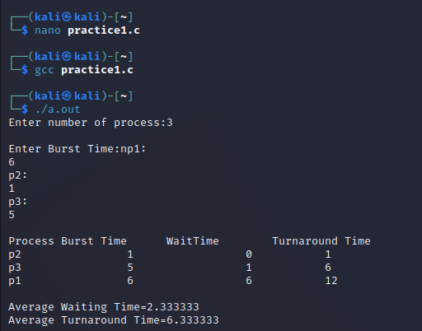

**2.**

#include <stdio.h>

int main()

{

int pid[15];

int bt[15];

int n;

printf("Enter the number of processes: ");

scanf("%d",&n);

printf("Enter process id of all the processes: ");

for(int i=0;i<n;i++)

{

scanf("%d",&pid[i]);

}

printf("Enter burst time of all the processes: ");

for(int i=0;i<n;i++)

{

scanf("%d",&bt[i]);

}

int i, wt[n];

wt[0]=0;

//for calculating waiting time of each process

for(i=1; i<n; i++)

{

wt[i]= bt[i-1]+ wt[i-1];

}

float twt=0.0;

float tat= 0.0;

for(i=0; i<n; i++)

{

printf("Process:%d\n", pid[i]);

printf("burst time:%d\n", bt[i]);

printf("waiting time:%d\n", wt[i]);

//calculating and printing turnaround time of each process

printf("turnaround time:%d\n", bt[i]+wt[i]);

printf("\n");

//for calculating total waiting time

twt += wt[i];

//for calculating total turnaround time

tat += (wt[i]+bt[i]);

}

float att,awt;

//for calculating average waiting time

awt = twt/n;

//for calculating average turnaround time

att = tat/n;

printf("Avg. waiting time= %f\n",awt);

printf("Avg. turnaround time= %f",att);

}

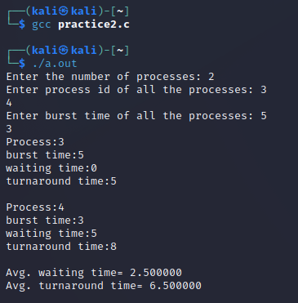

**3.**

#include <stdio.h>

int main()

{

int A[100][4]; // Matrix for storing Process Id, Burst

// Time, Average Waiting Time & Average

// Turn Around Time.

int i, j, n, total = 0, index, temp;

float avg_wt, avg_tat;

printf("Enter number of process: ");

scanf("%d", &n);

printf("Enter Burst Time:\n");

// User Input Burst Time and alloting Process Id.

for (i = 0; i < n; i++) {

printf("P%d: ", i + 1);

scanf("%d", &A[i][1]);

A[i][0] = i + 1;

}

// Sorting process according to their Burst Time.

for (i = 0; i < n; i++) {

index = i;

for (j = i + 1; j < n; j++)

if (A[j][1] < A[index][1])

index = j;

temp = A[i][1];

A[i][1] = A[index][1];

A[index][1] = temp;

temp = A[i][0];

A[i][0] = A[index][0];

A[index][0] = temp;

}

A[0][2] = 0;

// Calculation of Waiting Times

for (i = 1; i < n; i++) {

A[i][2] = 0;

for (j = 0; j < i; j++)

A[i][2] += A[j][1];

total += A[i][2];

}

avg_wt = (float)total / n;

total = 0;

printf("P BT WT TAT\n");

// Calculation of Turn Around Time and printing the

// data.

for (i = 0; i < n; i++) {

A[i][3] = A[i][1] + A[i][2];

total += A[i][3];

printf("P%d %d %d %d\n", A[i][0],

A[i][1], A[i][2], A[i][3]);

}

avg_tat = (float)total / n;

printf("Average Waiting Time= %f",avg_wt);

printf("\nAverage Turnaround Time= %f",avg_tat);

}

